UXP-JavaScript-L1-0001: JavaScript User login form

Level: L1

Technologies: JavaScript, HTML5, CSS3, Bootstrap**.**

Case Study: To create login form with form validation.

**Tips to start**

**Case Study – Login Form with validation**

Visual:

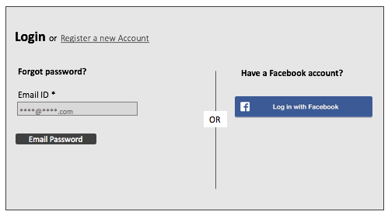

Error

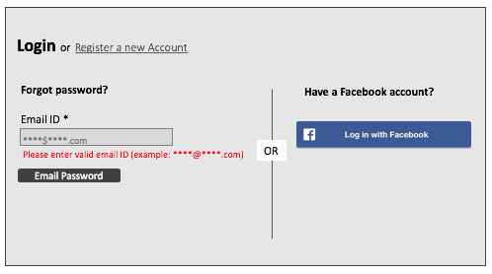

**Getting Started:**

Bootstrap your HTML page, create a HTML5 page with CSS3 and form validation with help of JavaScript.

**Dependencies:**

Develop html page using bootstrap framework and apply form validation with JavaScript. Refer the links below.

Bootstrap: <http://getbootstrap.com/>

**Additional notes:**

* Create a table in HTML5.
* Create a simple login form with the fields as shown in the Picture above.
* Use placeholders for the input fields.
* <table><tr><td> should not be used.
* Email validation should be done.
* If user fills the wrong email id error message should be displayed.